Geotecnical Engineering Problems and tentative solutions in Thailand

Suttisak Soralump, Ph.D.
Geotechnical Engineering Research and Development Center
Civil Engineering Department, Faculty of Engineering
Kasetsart University, Bangkok, Thailand
Abstract

This paper discusses the geotechnical engineering problems in Thailand and the solution that practiced in the country. The overview of the geology of the country shows the cause of the problems. Two main problems are discussed which are the problems related to the thick soft clay deposit and the landslides problems. The bearing capacity of the foundation, the stability of the excavation work and excessive settlement of the earth structure are the problems that caused by thick and very soft Bangkok clay. The tentative solutions such as the ground improvement techniques, the development of bored pile foundation and diaphragm walls were discussed. Another discussion is the landslides problem. The trend of the research works and the solutions are presented. Bioengineering and the computer program that incorporated the benefit of the roots system for slope protection were discussed.

Introduction

Geotechnical engineering in Thailand play important role in the infrastructure development since the geology of the country tend to cause engineering problems. However, many construction projects and research developments in a past decade have been exciting for Thai geotechnical engineers, for example the construction of new Bangkok international airport, the first underground train system project, the first sky train system in Bangkok, the construction of the largest RCC dam in the world, the use of ground improvement techniques in many new highways system, the development of bioengineering for slope protection, the development of the bored pile and diaphragm construction. Those projects come with the unique problems but created great development in Thai geotecnical engineering society.

Geology of Thailand

Thailand situated in the Southeast Asian region. The general geographic of the country (Figure 1) consists of the mountain area in the northern part and the long mountain ridge extends to the western and the southern part. The northeastern part is large area of plateau. The central part of the country is the flat area, which made of the sediment from the mountain in the surrounding area. Sediment soil in the central plane of the country can be distinctly divided into two types (Poopath, 2003). One is the Fresh-water sediment, which covers the upper part of the land area, while the other, the deltaic sediment, covers the outlet of the Chao Phya River in the lower region. Since the deltaic sediment is mainly soft clay with an average thickness of about 15 meters, various constructions had faced the difficulties. Bangkok city situated in the lower region of the central part and close to the Gulf of Thailand, the development of the infrastructure in the capital city is directly encountered with the soft soil deposit.
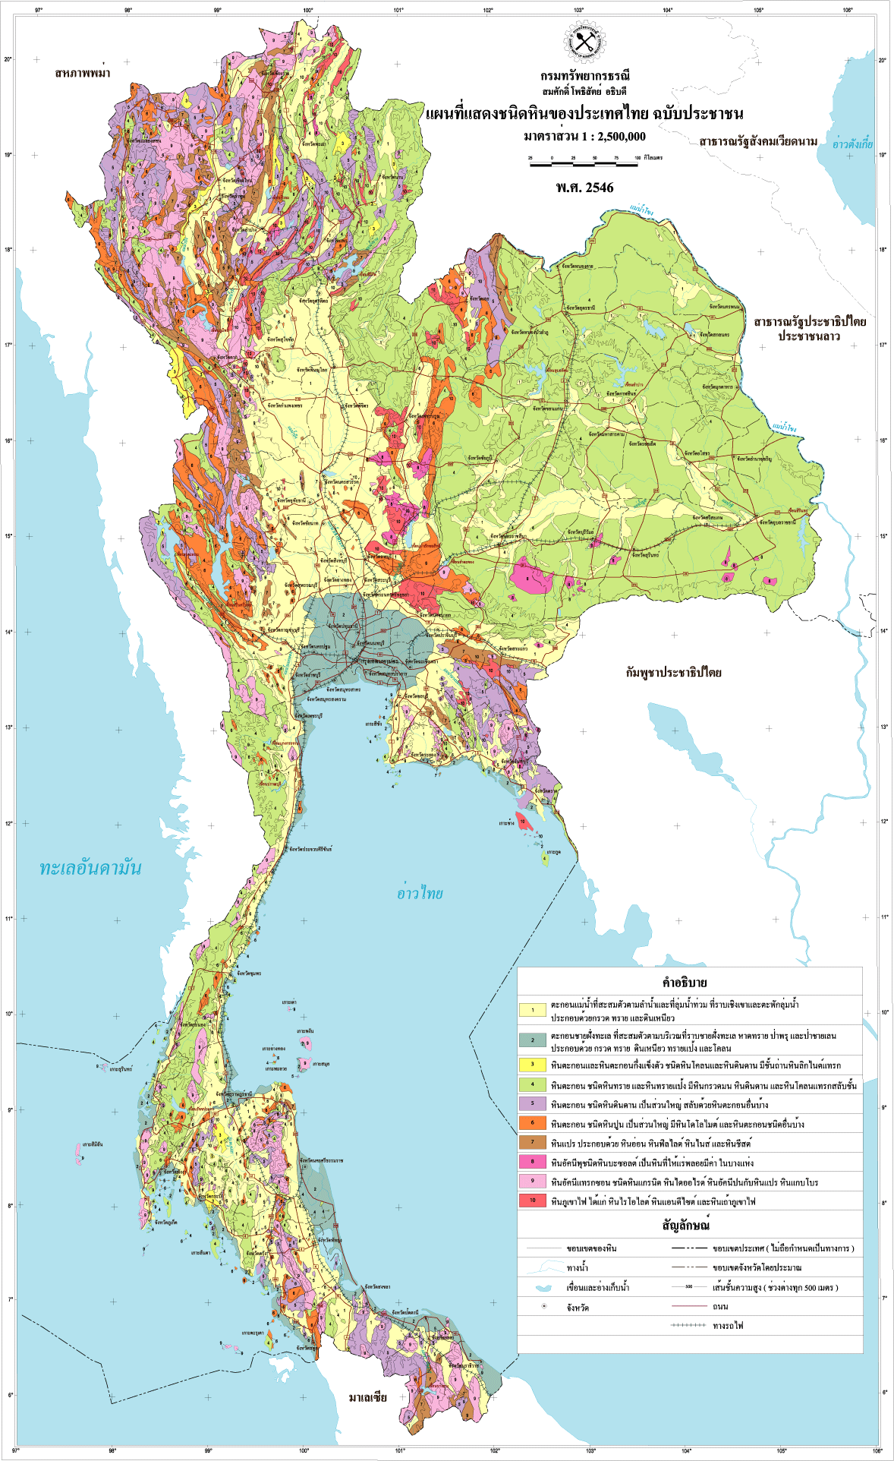

Figure 1. Geologic map of Thailand.

Soft clay related problems

As discussed above, it can be seen that the city of Bangkok and surrounding area is situated over the thick deposit of soft clay. The typical soil profile of Bangkok subsoil is shown in the Figure 2. The ground water table is level at about 1 to 2 meters below the ground surface. The subsoil consists of the layer of top crust underlain by the soft to very soft clay, which has the thickness of about 8 to 15 meters. The closer to the Gulf of Thailand, the thicker the soft clay deposit can be found. The water content of the soft clay is ranged from 80-140 %. The liquidity index is range from X to XX. The shear strength of soft Bangkok clay is quite low and ranged from 0.6 to 1.5 t/m3. The soft to very soft clay layer is underlain by the medium and then stiff clay layer. The series of clay layers are underlain by the first sand layer, which located at about 20 meters depth. Pile tip of the low-rise buildings are located here. Beneath the first sand layer are the series of the stiff clay layer followed by another sand layer and so on. The bedrock is estimated at the depth of 500 to 1000 meters from ground surface.
As the properties shown, soft Bangkok clay can be described as a thick deposit of soft to very soft clay with low shear strength and very high water content, high plasticity and stay mostly in the liquid state. Therefore, Geotechnical engineering plays important role in the construction in Bangkok and vicinity area. Many researches have been investigated in order to accurately predict the behavior of soft Bangkok clay.

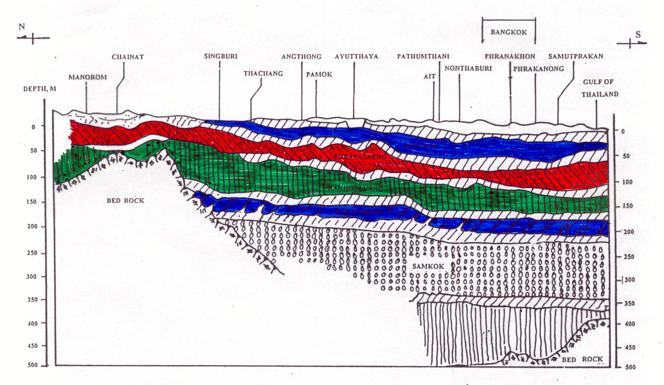
Figure 2. The general soil profile of Bangkok subsoil.

Bearing capacity and stability problems

The thickness and low shear strength of soft clay causes the low bearing capacity and stability problems. Thai ancestors have developed foundation technique that used to increase the bearing capacity of soft soil for almost 2000 years ago. The early techniques has been done, for examples, preloading of Phra Prathom Chedi pagoda, shallow compaction, floating foundation by series of lying logs, step footing, short wooden pile, pottery embedded foundation, etc. Those were the early techniques where concrete pile was not known. Now, pile foundation is a common practice for building foundation. For the common structures where the building load are not too large, the pile have to drive through the soft soil and tip at the first sand layer which stay at about 20 meters deep. For the high-rise building, the pile tip has to place in the second sand layer, which located at about 50 meters from ground surface and only the bore pile technique can be done. Therefore, it is not uncommon for the building in Bangkok area that the foundation cost is almost half of the total structural cost.
The problem of low bearing capacity of the soft soil can be solved commonly by transferring the load to the firm layer by the piles. Many researches in Thailand have been done to improve the piling technique in both construction and design, for example, the use of polymer-based slurry to improve the construction time and increase bore pile capacity (Thasnanipan et al, 2002).
Beside the advancement in pile foundation for buildings that solved the bearing capacity problem pretty well, another challenge problem from the thick and soft clay deposit is the excavation work problems. These excavation works include the excavation work for underground constructions, excavation work for foundation and etc. The problems are found in the form of the instability of the retaining structures, the excessive lateral displacement and etc. Therefore, it is uncommon for the small building in Bangkok area to have a basement room. However, for the high-rise buildings in the prime area, underground works are common. Conventional sheet pile with bracing system is normally used for the temporally excavation, the excessive lateral displacement cannot be avoided in some area. Diaphragm walls are normally used as a permanent structure for deep excavation. Barrette piles were cooperated in the diaphragm wall to increase the stability of the system and proved to be successful (Thasnanipan et al, 2000). However, some failure happened and the lesson has been learnt. The collapse during construction of an inlet pumping station in 1997 brought concern to geotechnical engineers in Thailand about the design of deep excavation without adequate attention to the instrumentations and monitoring system (Teparaksa, 1999). Figure 3 shows the plan view and the failure.

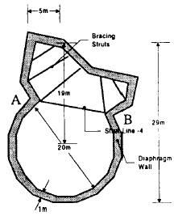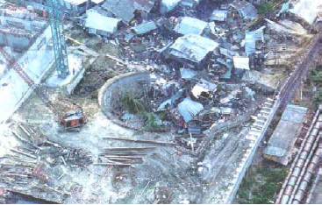

Figure 3. Collapse of an inlet pumping station (Teparaksa, 1999).

Post-construction excessive settlement

Beside the bearing capacity and stability problems, the post-construction excessive settlement is also the main problem of the earth structure in Bangkok area. The consolidation settlement of the soft Bangkok clay due to the construction load is large and takes long time. The highway embankment faced this problem directly. Many main highways had to be reconstructed after few years of service since the highway sink too much. Serious studies had been performed to monitor and study the settlement behavior of the highway (Bergado et al, 1990). Moreover, decades ago the plan of new Bangkok international airport was set up. Many researches have been done for decades in the target location in order to study the behavior of soft clay improved by preloading and vertical drain technique (Bergado et al, 1997). Ground improvement technique has been increasing used and developed for highways. So far, two kinds of ground improvement technique have been used which are, first, the technique to accelerate the consolidation process by drain the water out of the clay. Those techniques are such as the preloading and the vertical drain technique. Today, prefabricated vertical drain is commonly used in highway construction (Ruenkrairergsa, 1997). The technique has been proven to be successful in many highways. The foundations of runways of the new Bangkok international airport were also treated by vertical drain technique. Second kind of the technique to reduce the excessive settlement is the technique of transferring the embankment load to the firm stratum based on the pile foundation concept. Using piled embankment, soft clay deposit is no longer taken most of the embankment load and the settlement will be limited. In the past concrete pile has been used in a highway construction but did not satisfy due to the high construction cost (Siripanoosatien, 1993). Therefore, soil-cement column technique has been studied and used in the highway construction because of more acceptable cost than concrete pile and short construction period than the vertical drain technique (Soralump, 1999). Moreover, soil-cement column was also used as the retaining structure for the underground work and slope protection.
Differential settlement between the on-pile and on-earth structure is also a problem of the highway in both structural damage and traffic obstruction. The approach of the bridge is the example. The attempt of using the lightweight material as a fill material is still in the process. The uses of PVD and soil-cement column technique have proved to be helpful.

Landslide problems

Landslides are one of the disasters that killed people and damage the economics. The behavior of the landslides has been investigated by various government sectors since this problem is a national issue. The causes of landslides are from the natural and man-made factors. The weathering processes, transported soil mechanism, reduction in strength of unsaturated soil, unusual rain fall and cycle of the nature that attempts to balance the natural slope are all the natural factors that can be monitor but hard to control. The man-made factors are the illegal forestry, development without proper planning and the development without adequate knowledge. Geotechnical Engineering Research and Development Center (GERD), located in Kasetsart University, Bangkok, perform the serious researches of the landslides behavior in various aspects. Unsaturated soil behaviors were studied in the landslide area, both laboratory investigations and field monitoring works were done. The details investigations and evaluations were done in some landslide area as shown in Figure 4.

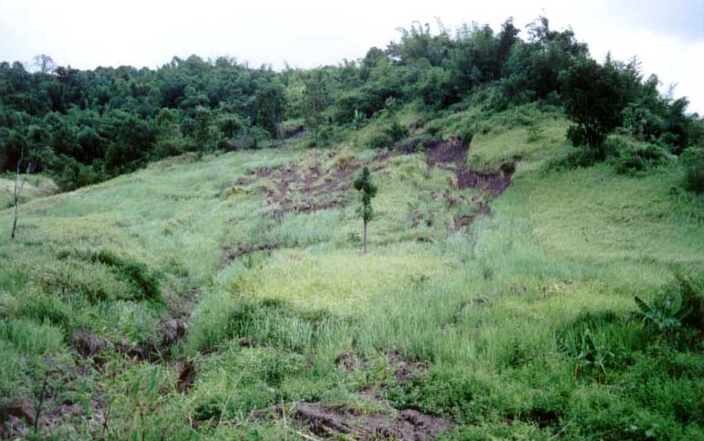
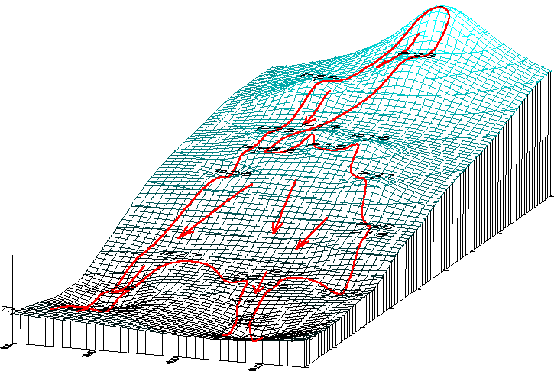

Figure 4. The analysis of the landslides.

The landslide database of the country is developing. Moreover, the landslide hazard map has been developed, however, new information needs to be included such as the unsaturated soil behavior, therefore, the engineering hazard map and risk analysis are in the target.
Even though the studies of the landslides behaviors are well performed but the prediction is still far from perfect. Prevention can be done by various method such as unloading, buttressing, drainage, reinforcement, retaining wall, vegetation, surface slope protection, soil hardening (Chearnkiapradab and Mairaing, 2002). Because of the cost, these preventions have to be used only in limited area where the civil works encounter with the nature or another word, these prevention can be use to prevent only some man- made landslides but not the natural one. This is because the natural landslides can occur in the vast area. Therefore, the study of hazardous area due to flash flood or landslide or other natural disasters has to be done before the development.
Slope stabilization by bioengineering method has been used vastly in Thailand. The root system can be used for surface slope protection and also increasing the stability of the slope. Studies have been done with common and easy to grow plant. Shear strength of the root system were studied. The slope stabilization using the root system is incorporated into the computer program KUslope (Mairaing and Chitjherchun, 2001). The concept of the analysis is the modeling of the roots as shown in Figure XXX.

Conclusion

From the problems and example of the solutions discussed, it can be seen that those problems or the tentative solutions are neither relied only on the pure geotechnical engineering concepts. The tentative of using the multi-disciplinary, the study of the society needs and environmental friendly concept should be the great concern for the young geotechnical engineers.

References

Bergado, D.T., Ahmed S., Casan L. Sampaco, and A.S. Balasubramaniam, 1990. “Settlement of Bangna-Bangpakong Highway on Soft Bangkok Clay”, Geotechnical Engineering, Vol. 116, No. 1, January, PP.136-154

Bergado, D.T., A.S. Balasubramaniam, R.J. Fannin, L.R. Anderson, and R.D. Holtz, 1997. “Fullscale field test of prefabricated vertical drain (PVD) on soft Bangkok clay and subsiding environment”, Ground Improvement, Ground Reinforcement, Ground Treatment Development 1987-1997, ASCE Geotechnical special publication No. 69

Chearnkiatpradab, B., Warakorn Mairaing, 2002. “Evaluation of soil slope stabilization case studies: Bangpakong river basin and Namkor watershed area” Proceedings of the Eighth National Convention on Civil Engineering, October 23-25 2001, Khon Kaen, Thailand

Mairaing, W., Chulert Chitjherchun, 2001. “The slope stability analysis computer program: the development in Thailand” Seminar of Highway Engineering, Highway Department, Thailand.

Poopath, V., 2002. “Geotechnical and foundation condition on Bangkok and central region”, Proceedings of the Eighth National Convention on Civil Engineering, October 23-25 2001, Khon Kaen, Thailand

Ruenkrairergsa, T., S. Sunantapongsak, S. Apimethethamrong, and P. Boontharaksa, 1997. “Use of prefabricated vertical drain (PVD) for settlement acceleration of the Bangkok-Chonburi new highway’, The First Seminar on Ground Improvement in Highways, Department of Highways, Bangkok, Thailand.

Siripanoosatien, P., 1993. “Behavior of a road embankment on relief piles at Thon Buri-Pak Tho highway (Km15+000)” M.Eng Thesis, Department of Civil Engineering, Chulalongkorn University, Bangkok, Thailand.

Soralump, S., D.T. Bergado and A.S. Balasubramaniam, 1999. “Soil cement deep mixing method for rehabilitation of Bangna-Bangpakong highway” 34th Symposium on Engineering Geology and Geptechnical Engineering, Utah State University, Logan Utah

Teparaksa W., Thasnanipan N., Maung A. W. and Tanseng P., 1999, “Lessons from the collapse during construction of an inlet pumping station: Geotechnical instrumentation aspect”, 5th International Symposium on Field Measurements in Geomechanics, Singapore, p.p. 247-252.

Thasnanipan, N., Maung A.W. & Ganeshan B., 2000. “Diaphragm Wall and Barrette Construction for Thiam Ruam Mit Station Box, MRT Chaloem Ratchamongkhon Line, Bangkok,” An International Conference on Geotechnical & Geological Engineering, Melbourne, Australia, 19-24 November 2000

Thasnanipan, N., Zaw Zaw Aye, Chanchai Submaneewong and Wanchai Teparaksa, 2002. “Performance of Wet-Process Bored Piles Constructed with Polymer-Based Slurry in Bangkok Subsoil”, Proceedings of the International Deep Foundations Congress 2002, Geotechnical Special Publication No. 116, Volume One, American Society of Civil Engineers, February 14-16 2002, Orlando, Florida, USA, p.p. 143-157

